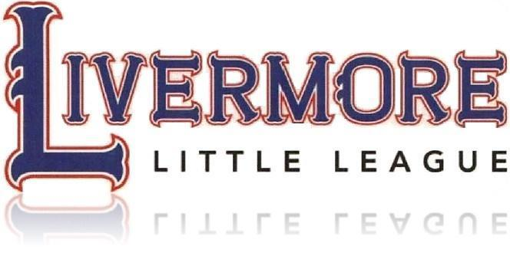
Established 2015

2023 Safety Manual

Play It Safe
League ID Number
405-57-12

Livermore Little League
Livermore, California 94551

Table of Contents
Livermore Little League (LLL) 1
A.S.A.P. 3
Contacts 4
2022-2023 Board of Directors 4
2023 Training Calendar 4
Fields 5-7
Safety Pointers for Coaches (Note: Greenbook® & LLL local rules supersede this safe-play summary) 11
LLL Code of Conduct 12
Safety Code 13-14
FIRST AID 15
California Concussion Requirements: 16
Concussions: 16
Concussion Information Sheet for Players and Parents 17-19
INJURY REPORT FORM 20
First Aid Training 21
Volunteer Background Check 22
Snack Shack Safety 23
Storage Shed/Bin Procedures 24
Safety is EVERYONE’S responsibility 24
Emergency Procedures 25-26
Claim Form Instructions 27-29
Accident Claim Form 30-31
FUNDAMENTALS TRAINING: All Pro Baseball Coaching Clinic 32
Team/Coach Checklist: 33
Medical Release Form: 34
Pitching & Catching Affidavit 39
Livermore Little League (LLL)
is a chartered member of Little League Baseball, which is headquartered in Williamsport, Pennsylvania. We are in District 57 of the Western Region, which is headquartered in San Bernadino, California. Our boundaries are predetermined by District 57 and do not follow school boundaries.
Divisions
Livermore Little League supports the following:
- T-Ball Division for league ages 4 – 5
- Rookie Division for league ages 5 – 6
- A (‘Single A’) for league ages 6 – 8
- AA (‘Double A’) for league ages 7 - 9
- AAA (‘Triple A’) for league ages 9 - 11
- Major Division for league ages 10 - 12
- Intermediate Division for league ages 11 – 13
- Junior Division for league ages 12 – 14
- Seniors Divisions for league ages 14 – 16
- Challenger Division for league ages 5-18

The mission of Livermore Little League is to provide quality baseball experiences to Livermore youth in a safe environment that balances integrity, respect, competition, fun, and fair play.

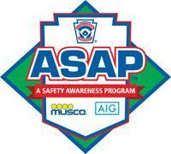

A.S.A.P. In 1995, ASAP (A Safety Awareness Program) was introduced with the goal of reemphasizing the position of Safety Officer "to create awareness, through education and information, of the opportunities to provide a safer environment for kids and all participants of Little League Baseball." This manual is offered as a tool to place some important information at manager's and coach's finger tips. Paper copies of this manual will be distributed to all Managers, concession stands, facilities crew and common areas accessible by volunteers. The manual will also be posted to www.livermorelittleleague.com.

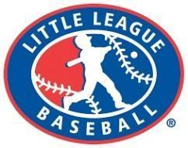

Contacts
Livermore Police - Non-emergency (925) 371-4987
Livermore Fire - Non-emergency (925) 454-2361
Stanford Valleycare Medical Center (925) 447-7000
Power/Gas (PGE) Emergency Line (800) 743-5000 (option 1)
Poison Control (800) 222-1222

2022-23 Board of Directors
Position | Name | Phone | Email
President | Eddie Vaca | 562-304-3035 | president@livermorelittleleague.com
Vice President | Nicole Von Glahn | 650-465-8545 | vp@livermorelittleleague.com
Secretary | Gena Ruggeri | 925-321-0274 | john@livermorelittleleague.com
Treasurer | Dean Scotch | 925-583-4349 | treasurer@livermorelittleleague.com
Info Officer | Megan Williams | 925-519-8874 | info@livermorelittleleague.com
Fields | Kenny Wheeler | 925-596-5282 | LLLfields@livermorelittleleague.com
Coaching Coordinator | John Lange | 925-784-6170 | coaching@livermorelittleleague.com
Upper Div VP | Eddie Vaca | 562-304-3035 | ud@livermorelittleleague.com
Player Agent | Jason Rafferty | 925-321-5483 | playeragent@livermorelittleleague.com
Safety Officer | Kari Weber | 415-685-6729 | safety@livermorelittleleague.com
UIC | Johnny Ruiz | 925-922-8692 | uic@livermorelittleleague.com

2023 Training Calendar
Date | Training | Who must attend?
1/23-1/26 | Draft | Team Manager (Single A and up).
2/6/23 | LARPD Felds Open | No practices on LARPD fields prior to this date
2/13/23 | Team Parent Night | 1 Team parent volunteer (or 1 coach if no team parent is available). 6-7pm TeeBall-Rookie 7:15-8pm AA-UD on 2/16, Rookie and Tball 2/22:Stockman’s
2/17/23 | Game Changer Training | At least 2 scorekeeper volunteers
2/18/23 | First Aid Training  Field Prep Training | At least 1 manager or coach (all Divisions/Levels)  At least 2 volunteers per team
 | Coaching Clinic | Managers and coaches
2/25/23 | Umpire Clinics/ Rules Clinic | All umpires, 8am – 12pm, Robert Livermore Fields
3/4/23 | Opening Day | All managers, coaches and players

Fields

Jackson Elementary Fields
558 Jackson Ave (Access from LeeAnn Circle)
Tee ball, A Division (north field) and AA Division (south field)
Services: Outhouses, batting cages. No food/water available.
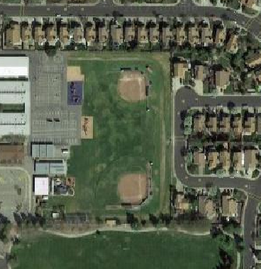

Robert Livermore Fields
491 Loyola Way
Tee ball – AAA (East field)
Majors – Intermediate (Dutch Van Wey)
Services: Restrooms, Snack Shack with AED, water
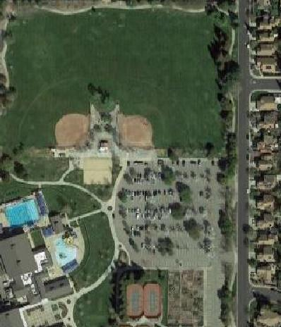

William (Bill) Payne Fields
5800 Patterson Pass Road
Intermediate and Junior Division Fields
Services: Outhouses, water. No food services.
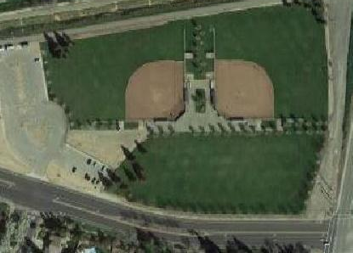

Ernie Rodriguez Fields
1505 S. Livermore (corner of S. Livermore & Concannon)
Tee ball through Junior (northwest field).
Services: Restrooms, Snack Shack, water
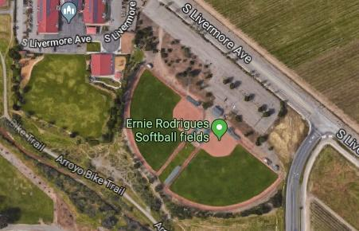

Altamont Creek Park and Field
6544-6634 Altamont Creek Dr, Livermore, CA 94551
Tee ball – AAA
Services: None
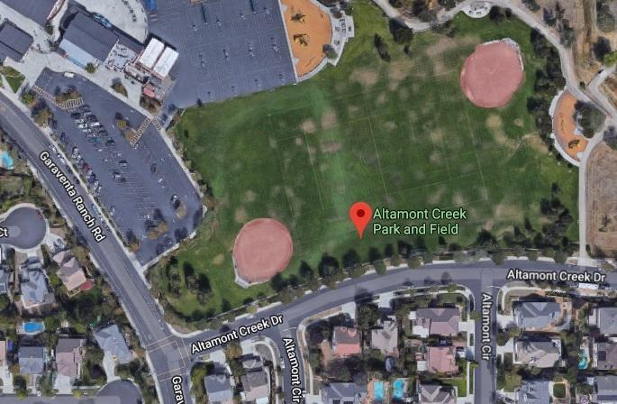

Randy Johnson Field at May Nissen Park
685 Rincon Ave, Livermore, CA 94551
Tee ball – AAA (East field)
Services: None
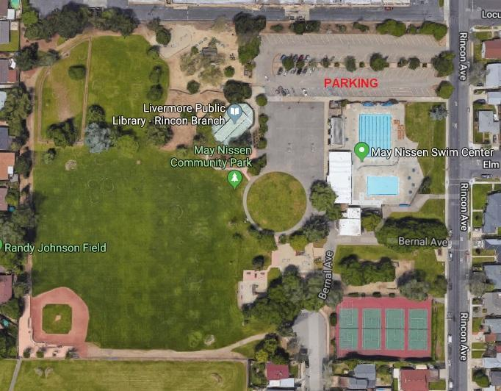
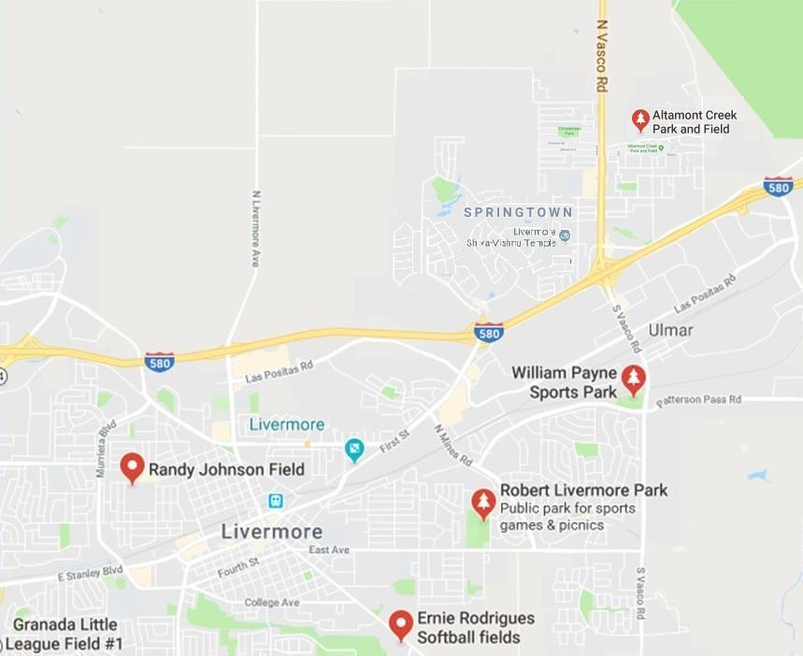

Managers/Coaches Expectations:

Are your expectations reasonable and consistent?
What do I expect from my players?
- To be on time for all practices and games.
- To always do their best in the field or on the bench.
- To be cooperative and share team duties.
- To respect not only others, but themselves as well.
- To be positive with teammates.
- To understand that winning is only important if you can accept losing, as both are a part of any sport.
- To try not to become upset at their own mistakes or those of others... we will all make our share and must support one another.

What can parents and players expect from me?
- To be on time for all practices and games.
- To be fair in giving playing time to all players.
- To attend all coach clinics (e.g. First Aid, Umpire Training, Rules Clinic, Ron Wotus Coaching Fundamentals, etc).
- To do my best to teach the fundamentals of the game.
- To be positive and respect each child as an individual.
- To set reasonable expectations for each child.
- To set reasonable expectations for the season.
- To prioritize safety for all athletes.
- To respect the umpire’s call.
- To teach the players the value of winning and losing.
- To be open to ideas, suggestions or help.
- To never holler at any member of my team, the opposing team or umpires. Any confrontation will be handled in a respectful, quiet and individual manner.

What can I expect from parents (and players)?
- To come out and enjoy the game.
- To cheer to make all players feel important.
- To allow me to coach and run the team.
- To not enter the dugout during games.
- To avoid open criticism of my leadership. All players will make mistakes and so will I. If you wish to question my strategies, please do not do so in front of the players or fans. My phone number will be available if you have a concern.
- To avoid unsportsmanlike conduct (i.e. cheering when an opponent strikes out or misses a catch). Doing so puts me in a difficult position as I am responsible for the behavior of my team’s fans. If we eliminate negative comments, the children will have an opportunity to play without any unnecessary pressures and will learn the value of sportsmanship.
- Do not make insulting comments to the umpires. We are all responsible for setting examples for our children. Unruly spectators can be ejected.

Finally, don't expect all children playing Little League baseball to have strong skills. We hear all our lives that we learn from our mistakes. Let's allow them to make their mistakes, but always be there with positive support to lift their spirits

Safety Pointers for Coaches (Note: Greenbook® & LLL local rules supersede this safe-play summary)
Background Checks
- All managers, coaches and coach-assistants must complete a background check, through JD Palatine (www.jdp.com).
- Any adult who interacts with children (umpires, provides rides, warms-up players, etc.) needs a background check.
- Email safety@livermorelittleleague.com to receive a link to an individualized online volunteer application.

Uniform and Gear
- All male players must wear a protective cup.
- No jewelry or unapproved accessories (medical alert bracelets are allowed).
- The brim of the cap protects the eyes from the sun or lighting and must be worn in the forward position.
- Batting helmets must be NOCSAE approved.
- No hoods, jackets, sweaters or coats (single A and above). During cold weather, long-sleeve undershirts are allowed.

Dugout Safety
- Bats must remain racked until the batter is ready to exit the dugout.
- Players or coaches must return the bat to the dugout before the next player bats. Bat-boys/girls are not allowed.
- At least 1 adult coach must remain in the dugout.
- The on-deck batter must remain in the dugout until it’s his or her turn at bat (Tee-ball through Majors, only).
- Spectators are not allowed in the dugout during games.

Batter Safety
- Single A and below: No bunting.
- Always wear a helmet. A helmet with a faceguard is recommended for younger players. Helmets must be NOCSAE approved.
- Teach kids to turn away from an inside pitch as a direct hit to the chest could be life-threatening.
- Throwing the bat for any reason is not allowed. Teach your on-deck players to retrieve the bat after every hit or walk. Never allow a player to throw it back to the dugout.

Catcher Safety
- Catchers must wear a mask with dangling neck guard during practice and games.
- The free (non-gloved hand) should be positioned behind the back or behind the back of the leg in young catchers to avoid throwing-hand injuries.
- The moment the pitch is thrown, the catcher must be initially positioned directly behind the plate with their weight on the balls of their feet. Young catchers who kneel (instead of squatting) are at greater risk for ball-strikes to the abdomen, thigh and knee.
- In Little League, the catcher cannot block the plate by waiting in the runner’s line without the ball.
- Teach young catchers to always keep their mask & helmet on. According to a recent John’s Hopkins study, non-collision concussion injuries for catchers are far more common that those stemming from collisions and rank 3rd overall in catcher injuries.
- Teach young catchers not to move forward into range of the bat’s arc, especially common when reaching forward for a low pitch.
- After 41 pitches, a player is no longer eligible to catch in the same game.
# pitches | Days of Rest | If pitching on Saturday…
1 to 20 | 0 | OK to pitch Sunday
21 to 35 | 1 | OK to pitch Monday
36 to 50 | 2 | OK to pitch Tuesday
51 to 65 | 3 | OK to pitch Wednesday
66 to max | 4 | OK to pitch Thursday

Pitcher Safety
- Pitching limits: 13/16 ≤ 95 pitches, 11/12 ≤ 85 pitches, 9/10yrs ≤ 75 pitches, 8/9yrs ≤ 50 pitches. These numbers are reduced by 10 before spring break.
- Scorekeepers may alert umpires when a pitcher nears his/her limit.
- Adults may not “warm-up” a pitcher on game-day.
- Minimum calendar days of rest for pitchers must always be observed 🡪
- You cannot pitch more than 3 days in a row.
- Local rules may stipulate reduced pitch counts for the first half of the season.

Unsafe Conditions
- When dealing with inclement weather or darkness, umpire and managers must agree conditions are safe for play.
- Standing water, mud, divots/holes, imbedded stones, slippery conditions, etc, may warrant field closure if irreparable.
- Do not play when lightning, extreme heat, poor air quality/smoke/smog or poor visibility conditions exist.
- Fields closed by Livermore Little League Officials or LARPD are off-limits for games and/or practice.
Coach Safety
- Defensive coaches must stay in the dugout during play with the gate door closed. (There is no valid reason for a live game ball to find its way into the defensive team’s dugout if this rule is followed.)
- Offensive coaches must stay within the coach box (chalk lines).
- Tee-ball and Farm: Coach pitch only from either a standing or kneeling position as allowed by Green-book and local rules.
- Single A coaches must pitch at least 30 feet from home plate from a kneeling or standing position. Double AA coaches must pitch overhand from the mound. The pitching coach must maintain spatial awareness of the ball, as watching the runner can result in being hit from behind by a thrown ball. If the pitching coach can’t easily exit the field during the play, they should move to an area of the infield where interference is less likely to occur or crouch down in front of the plate to lower their profile.
- Coaches on the field are vulnerable to injury. When in the coach box, we tend to watch the whole field and in doing so risk losing focus on the batter. And when pitching we must recognize that our reflexes may not be as quick as our players. Wear appropriate safety gear (e.g. cup) and consider bringing your glove to the mound as play interference is better than a concussion.

Player’s Wellbeing and Development
- No player may sit out two innings in a row.
- Each player must play defense at least 4 innings (A – AAA).
- Each player must play INFIELD at least 2 innings (A and AA) and 1 inning (AAA).
- Each player must play OUTFIELD at least 1 inning (A – AAA).
- In AA and below there is no scoring on an overthrow to 3rd unless 3rd base is already occupied.
- In AA and below there is no advancing of runners once an outfield hit is thrown back to an infielder or touches the infield dirt, past the base they are running to or currently at.
- There is zero tolerance for physical or emotional abuse (e.g. bullying) of players.
- Coaches are mandated reporters and as such, are responsible for reporting suspicion or direct knowledge of physical abuse or sexual abuse of a child. (Per California law for Mandated Reporters)

All Green Book and Local Rules will be enforced!
Some Important Do’s and Don’ts

Do ...  - Reassure and aid children who are injured, frightened or lost.  - Provide (or obtain) medical attention for those who require it.  - Assist those who require medical attention but know your limitations.  - When administering aid, remember to ...  - LOOK for signs of injury (Blood, bruising, deformity of joint, etc.).  - LISTEN to the injured describe what happened and what hurts. Be calm and soothing when speaking to an excited child.  - FEEL gently the injured area for signs of swelling or broken bone.  - Have your players' medical clearance forms with you at times.  - Have a cell phone available with parent numbers pre-programed. | Don't ...  - Administer any medications.  - Provide any food or beverages (other than water).  - Hesitate in giving aid when needed.  - Be afraid to ask for help if you're not sure of the proper procedures.  - Transport injured (except in extreme emergencies).  - Leave an unattended child at a practice or game  - Hesitate to report any present or potential safety hazard to the Safety Officer.

Managers/Coaches Expectations:
Are your expectations reasonable and consistent?
What do I expect from my players?
- To be on time for all practices and games.
- To always do their best in the field or on the bench.
- To be cooperative and share team duties.
- To respect not only others, but themselves as well.
- To be positive with teammates.
- To understand that winning is only important if you can accept losing, as both are a part of any sport.
- To try not to become upset at their own mistakes or those of others... we will all make our share and must support one another.

What can parents and players expect from me?
- To be on time for all practices and games.
- To be fair in giving playing time to all players.
- To attend all coach clinics (e.g. First Aid, Umpire Training, Rules Clinic, Ron Wotus Coaching Fundamentals, etc).
- To do my best to teach the fundamentals of the game.
- To be positive and respect each child as an individual.
- To set reasonable expectations for each child.
- To set reasonable expectations for the season.
- To prioritize safety for all athletes.
- To respect the umpire’s call.
- To teach the players the value of winning and losing.
- To be open to ideas, suggestions or help.
- To never holler at any member of my team, the opposing team or umpires. Any confrontation will be handled in a respectful, quiet and individual manner.

What can I expect from parents (and players)?
- To come out and enjoy the game.
- To cheer to make all players feel important.
- To allow me to coach and run the team.
- To not enter the dugout during games.
- To avoid open criticism of my leadership. All players will make mistakes and so will I. If you wish to question my strategies, please do not do so in front of the players or fans. My phone number will be available if you have a concern.
- To avoid unsportsmanlike conduct (i.e. cheering when an opponent strikes out or misses a catch). Doing so puts me in a difficult position as I am responsible for the behavior of my team’s fans. If we eliminate negative comments, the children will have an opportunity to play without any unnecessary pressures and will learn the value of sportsmanship.
- Do not make insulting comments to the umpires. We are all responsible for setting examples for our children. Unruly spectators can be ejected.

Finally, don't expect all children playing Little League baseball to have strong skills. We hear all our lives that we learn from our mistakes. Let's allow them to make their mistakes, but always be there with positive support to lift their spirits

Reporting Child Abuse
Senate Bill 534, known as the Protecting Young Victims from Sexual Abuse and Safe Sport Authorization Act of 2017, has made it a crime to "mind your own business," in matters of child abuse or neglect.
All youth sports volunteers operating in the United States, including Little League volunteers, are obligated to notify authorities of any first-hand accounts of abuse or neglect of a minor. This information has been updated and reflected in Little League's Child Protection Program (https://www.littleleague.org/player-safety/child-protection-program).
In summary, the new law requires that suspected child abuse must be reported within 24 hours to local law enforcement. If a person suspects a case of abuse within their league, they should report it to the appropriate child services organization and/or law enforcement as well as their League President and the Safety Officer.

For child abuse training and awareness please visit: USA Baseball Abuse Awareness

LLL Code of Conduct

Speed Limit is 5 mph in roads and parking lots at all Livermore Little League functions. Watch for children around parked cars.

No alcohol allowed in any parking lot, field, or common areas. Those who arrive intoxicated will be asked to leave.

No playing in parking lots, walkways or on lawn equipment.

Only adults may operate lawn equipment and golf carts.

Use crosswalks when crossing roads and be alert for traffic.

No profanity or objectionable displays of dissent such as throwing hats, bats, gloves, balls, etc.

No swinging bats or throwing baseballs at any time within the walkways and common areas of a Little League complex.

No throwing balls against dugouts or against backstop.

Catchers equipment must be used for all batting practice.

No smoking or vaping. No tobacco products.

No throwing rocks.

No horseplay in dugouts or climbing of fences. Players must remain orderly in the dugouts during games.

Only a player at home plate may swing a bat. The on-deck position is NOT permitted in Tee Ball, Minors or Majors Divisions.

Bats must remain racked in the dugout until ready to approach the plate.

Be alert of area around you when swinging bat.

Abide by all posted signs, including, but not limited to: Field Closed, No Pets, No Parking, Reserved for Handicapped.

Players & fans should be alert for foul balls and errant throws.

After each game, teams must cooperate to clear trash in dugout and around the stands.

All gates to the field must remain closed. After players enter or leave the field, gates should be closed and secured.

No pushing, shoving or striking another person.

There is ZERO tolerance for physical, emotional, or sexual abuse.

Posted age restrictions should be honored inside the Snack Shack.

Weapons are not allowed at Little League events.

Safety Code
Dedicated to injury prevention

- Responsibility for safely procedures should be that of an adult member of Livermore Little League.
- Arrangements should be made in advance of at games and practices for emergency medical services.
- Managers, coaches and umpires should have training in first-aid. Each Manager is issued a first-aid kit. Extras are in the ‘Snack Shack’ concession stand at Robert Livermore Fields.
- No games or practices should be held when weather conditions are poor (i.e. Rain, lightning, extreme heat).
- No games or practices should be held when field conditions are poor (i.e. Soaked fields, puddling, mud).
- Before play, the Home Team Manager should inspect field for holes, damage, stones, glass or other objects.
- All team equipment should be stored within the team dugout, or behind screens, and not within the area defined by the umpires as 'in play.'
- Only players, managers, coaches and umpires are permitted on the playing field or in the dugout during games and practice sessions.
- Responsibility for keeping bats and loose equipment off the field of play should be that of a player assigned for this purpose or the team's manager and coaches.
- During practice and games, all players should be alert and watching the batter on each pitch.
- During warm-up drills, players should be spaced so that no one is endangered by wild throws or missed catches.
- All pre-game warm-ups should be performed within the confines of the playing field and not within areas that are frequented by and thus endanger spectators (i.e., playing catch, pepper, swinging bats, etc.).
- Equipment should be inspected regularly for the condition of the equipment as well as for proper fit.
- Batters, runners and catchers must wear protective helmets which meet NOSCAE (National Operating Committee on Standards for Athletic Equipment) specs and standards during batting practice and games.
- Catcher must wear catcher's helmet, mask, throat guard, long model chest protector, shin guards and protective cup with athletic supporter (males) for all practices and games, including warm-ups and bull pen practice.
- All male players must wear protective cups for practices and games.
- Except when runner is returning to a base, head first slides are not permitted (except in Juniors Division and up).
- Bats over 26” must be USA Bat-approved (Majors/Minors). Tee ball bats must be approved for use in tee-ball.
- Procedure should be established for retrieving foul balls batted out of the play area.
- During sliding practice, bases should not be strapped down or anchored.
- On-deck batters are not permitted (except In Juniors Division and higher).
- At no time should 'horse play' be permitted on the playing field or in the dugouts.

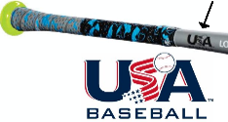
- Player must not wear watches, rings, pins or metallic items during games and practices.
- Managers and Coaches may not warm up pitchers at home plate, in the bull pen or elsewhere at any time.
- Only the pitcher and a batter are allowed inside a batting cage. The cage door must be closed when in use.
- Helmet attachments including face guards and C-flaps must be NOSCAE approved by the manufacturer. All 3rd party attachments that require helmet modification (e.g. drilling holes) are banned in Little League.
- All bases must disengage from their anchors.
- You cannot pitch more than 3 days in a row.
- All play shall follow Green Book Rules. Most Little League rules have some basis in safety, including the use of proper equipment during practices and games. Any modification, substitution or omission constitutes illegal play. Local rules may apply, but must not contradict or be less stringent than Green Book rules. Local rules are published on the Livermore Little League website and reviewed in the ‘Rules Clinic’ before the first game of the season.

Inclement Weather
Fields may be closed, or games and practices may be suspended in the event of inclement weather or poor air quality. Planned field closures will be announced on www.livermorelittleleague.com (usually by 2pm on weekdays and 7am on Saturdays). Game-time decisions will be made by the Adult umpire (or game monitor). Please do not call LARPD for field closure information, as most play decisions are made by league officials.

In the event of rain
- As a rule of thumb, games and practices should be postponed or canceled in the event of heavy rain (within an hour of gameplay), standing water on the field, muddy conditions or saturated outfield turf.
- If the weather is marginal, an adult umpire will make the call on the field.

In the event of lightning/thunder
- When thunder is heard, or lightning is seen, immediately stop the game and find shelter. If you cannot find shelter inside a nearby building, relative safety can be found in a car with the windows rolled up. Do not shelter in the metal dugouts. Do not hold a bat.
- Once 30 minutes have passed without any lightning, play may resume (pending umpire approval).
- All practices are immediately canceled in the event of thunder or lightning (for at least 2 hours).

In the event of extreme heat
- Generally, temperatures above 95ºF are unsafe for physical activity. Consider indoor practice instead.
- Outdoor games and practices should be rescheduled when temperatures exceed 100ºF.
- Players should be well hydrated. Coaches must provide water for athletes who do not bring their own.
- When heat is intense, schedule water/activity breaks every 15 – 20 minutes (in the shade if possible).
- Baseball caps help shade the head, face and eyes and must be worn when on the field.
- Players should be encouraged to bring and use their own sunscreen.

In the event of smog or smoky air
- The air quality index (AQI) is a number used by the EPA to assess air pollution.
- An AQI of 151 or higher (https://airnow.gov) is considered unhealthy for all. In this event, practices and games may be canceled.

In the event of wind storms, dust devils or strong gusting conditions
- Blowing dirt can pose a risk to an athlete’s ability to see and breathe. A prolonged wind storm may warrant postponement or cancellation of a game or practice, as determined by the umpire or coach.

Note: If the weather is questionable, please be aware we will try to play games rather than postpone games. Every effort will be made to get the fields ready. The safety of the children, however, is our priority. Although we want games to be played, we will not do so at the risk of the children.

FIRST AID
When treating an injury, remember:

Protect
Rest
Ice
Compression
Elevation
Support

First aid for cuts and wounds
- Help the person to remain calm. If the cut is large or bleeding heavily, have them lie down. If the wound is on an arm or leg, raise the limb above the heart to slow bleeding.
- Remove obvious debris from the wound, such as sticks or grass. If the object is embedded in the body, do NOT remove it.
- If the cut is small, wash it out with soap and water. Do NOT clean a large wound.
- After putting on clean medical gloves, apply firm pressure to the wound with a folded cloth or bandage for about 10 minutes. Do not remove the bandage to look at the wound during this time, as it may begin bleeding again. If blood soaks through, add another cloth or bandage and continue holding pressure on the cut for an additional 10 minutes.
- When bleeding has stopped, bandage the cut.
- Seek immediate medical care for wounds that are jagged or deep, on the face or genitals, involve an animal or human bite or if there is dirt inside that won’t come out after washing.

First aid care for broken bone
- If the person is unconscious or not breathing or moving, call 911 for medical help and begin CPR.
- Stop any bleeding. Apply pressure to the wound with a sterile bandage, a clean cloth, or a clean clothing.
- While waiting for medical care, give first aid treatment for shock if the victim has symptoms such as dizziness, weakness, pale and clammy skin, shortness of breath, and increased heart rate. The person should lie quietly with the feet elevated about 12 inches. Cover him or her with a blanket to maintain body warmth.
- Immobilize the injured area if you will be moving the victim. Do not move them if there is a back or neck injury. Make a splint by folding a piece of cardboard or newspaper or a magazine, then placing it gently under the limb. Carefully tie the splint to the injured area with pieces of cloth.

First Aid for swelling/contusions
- Apply a cold compress or ice in a plastic bag to the injured area. Make sure to place a cloth between the skin and the ice so you don't damage the skin.

Contact with blood or body fluids
- Use gloves when contact with blood is anticipated.
- Open wounds must be covered and the uniform changed if there is blood on it before the athlete may continue.
- Immediately wash hands/skin if contaminated with blood.
- Clean all blood contaminated surfaces and equipment.
- Managers, coaches, and volunteers with open wounds should refrain from all direct contact with youth players.
- Follow accepted guidelines in the immediate control of bleeding and disposal when handling bloody dressings, mouth guards and other articles containing body fluids.

Throwing injuries
- Growth plate fractures in the humerus of the throwing arm are too common. Maximum pitch counts must be strictly enforced followed by 3 full days (minimum) of rest for both pitchers and catchers.

Heat exhaustion
- Symptoms include: Headaches, nausea, vomiting, dizziness, heavy sweating, rapid pulse, fatigue.
- Athletes who are symptomatic must be hydrated and brought to a shaded cool area until symptoms abate.
- Without relief from the heat, heat exhaustion may progress to heat stroke, a potentially deadly condition requiring immediate medical attention.

Nose bleeds
- While sitting forward pinch the soft part of the nose.
- Bleeding rarely lasts more than 3-5 minutes.

Tooth Injury
- If a tooth is displaced, insert the tooth back into it’s socket, or store the tooth in milk (not water), or have the child hold the tooth in between the cheek and gum
- Seek medical care immediately.

Eye Injury
- Black eye: Apply a cold compress without pressure.
- Foreign object: Pull upper lid over lower to promote tearing.
- Seek medical care immediately.

Note: Children with inhalers/epi-pens should have them available for self-administration if needed. Fully stocked first aid kits are required at all games & practices.

Note: If a player misses more than 7 continuous days for an illness or injury, the team Manager must receive written permission from a medical provider for a return to full activity.

California Concussion Requirements:

California Assembly Bill No. 2007, Chapter 516, Section 1, Article 2.5, 124235a is summarized below:
- Youth athletes suspected of having a concussion must be removed from play for the rest of the day and may not return until cleared by a licensed health care provider. If a concussion is confirmed, a physician-approved graduated return to play of no less than 7 days is required.
- The athlete’s parents must be notified of the time/date of the incident and treatment details.
- On a yearly basis, ALL athletes and a parent must review and sign a concussion info sheet.
- Concussion training* must be offered to all administrators, managers and coaches.
- Administrators, managers and coaches must complete this training before supervising youth.
- Youth sports organizations must have procedures to ensure compliance with all of the above.

For more information visit: https://leginfo.legislature.ca.gov/faces/billNavClient.xhtml?bill_id=201520160AB2007

* Livermore Little League has determined that the CDC ‘head’s up’ online training sessions meet the training objectives outlined above. All LLL administrators, managers and coaches must complete the training at: www.cdc.gov/headsup. Participants will be issued a certificate upon completion. That certificate must be emailed to safety@livermorelittleleague.com to verify training has been taken.

The following information summarizes concussion signs/symptoms and LLL policies for management.

Concussions:
- A concussion is caused by a blow or jolt to the head or body that causes the brain to move rapidly back and forth. Even a mild hit to the head can be serious.
- Most concussions occur without loss of consciousness.
- Signs and symptoms of concussion can show up right away or may not appear for days or weeks after the injury.
- Young children and teens are more likely to get a concussion and take longer to recover than adults.
- Athletes who have at any point in their lives, had a concussion have an increased risk for another.
- In rare cases, repeat concussions in young athletes can result in brain swelling or permanent damage to their brain. They can even be fatal.
- Rest is key to helping an athlete recover from a concussion.
- Concussions affect people differently. While most athletes with a concussion recover quickly and fully, some will have symptoms that last for days, weeks or months.
- All athletes (and their parents) must review and sign the attached CDC concussion information sheet.

For more info visit: www.cdc.gov/Concussion

Concussion Information Sheet for Players and Parents – (signed during registration)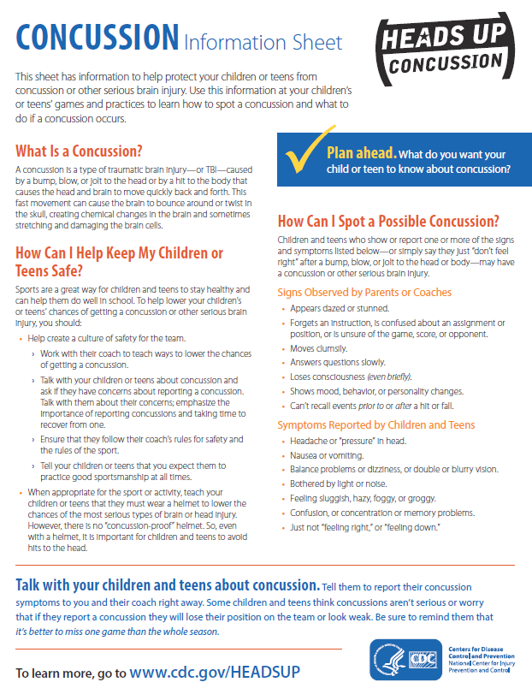

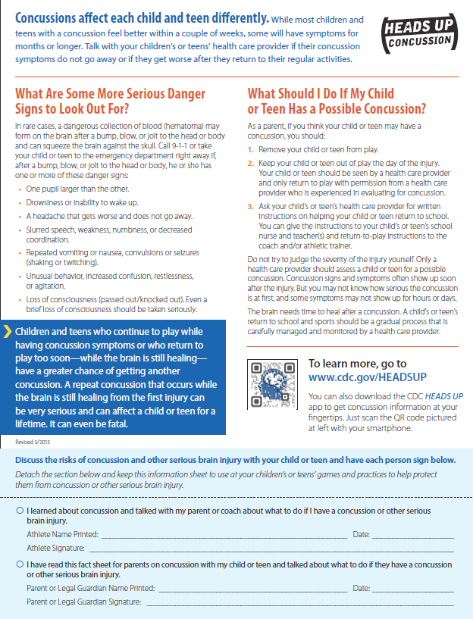

Concussion Information (continued)

Concussion Signs Observed .
- Can’t recall events prior to or after a hit or fall.
- Appears dazed or stunned.
- Forgets an instruction, is confused about an assignment or position, or is unsure of the game, score, or opponent.
- Moves clumsily.
- Answers questions slowly.
- Loses consciousness (even briefly).
- Shows mood, behavior, or personality changes

Concussion Symptoms Reported .
- Headache or “pressure” in head that does not diminish
- Nausea or vomiting.
- Balance problems or dizziness,
- Double or blurry vision.
- Bothered by light or noise.
- Feeling sluggish, hazy, foggy, or groggy.
- Confusion, concentration or memory problems.
- Just not “feeling right,” or “feeling down.”

In rare cases, a dangerous blood clot may form on the brain in a person with a concussion and crowd the brain against the skull. An athlete should receive immediate medical attention (by way of ambulance if necessary) if after a bump, blow, or jolt to the head or body s/he exhibits any of the following danger signs:
- One pupil larger than the other
- Is drowsy or cannot be awakened
- A headache that not only does not diminish, but gets worse
- Weakness, numbness, or decreased coordination
- Repeated vomiting or nausea
- Slurred speech
- Convulsions or seizures
- Cannot recognize people or places
- Has unusual behavior or becomes increasingly confused, restless, or agitated
- Loses consciousness (even a brief loss of consciousness should be taken seriously)

Concussion Action Plan
When a player receives a blow to the head or body and presents with one or more sign/symptom

- The athlete must be removed from play for the rest of the day and shall not return to active play until evaluated by a licensed health care provider. Do not try to judge the severity of the injury yourself.

- The Team Manager or coaching staff must notify the athlete's parents: (a) when the injury occurred, (b) symptoms observed and (c) any treatments provided on site.

- The Team Manager or coaching staff must complete a Livermore Little League Injury Report and email to the league safety officer within 24 hours (safety@livermorelittleleague.com). The Injury Report Form is available at http://www.livermorelittleleague.com and on the subsequent page of this manual.

- The player may not return to athletic activity until securing written clearance by a licensed health care provider stating s/he is symptom-free and it's OK to return to play.

- Rest is key for a full recovery. Returning to activity is a gradual process that should be carefully managed and monitored by a health care professional. If an athlete is diagnosed with a concussion, the health provider’s written clearance must include a graduated return to play plan of no less than seven days. The return to play protocol must be shared with the team manager and safety officer.

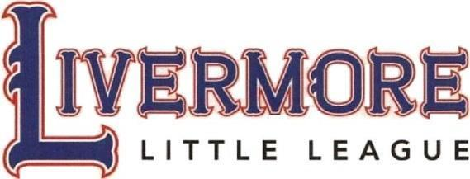

INJURY REPORT FORM
Report any incident that causes a player/coach/umpire to receive medical treatment and/or first aid.

Player Injured: ______________________________________ Time of Injury: ______________________

Name and phone number of person filling out this form: _______________________________________________

Date of Injury: ________________________ Age: ______________ Sex: M / F

Player Injured Address: _________________________________________________________________________

Player Injured Phone #: _______________ Field: ___________________________________________________

Exact location injured on the playing field: __________________________________________________________

Incident occurred during: Game ( ) Practice ( ) Other ( ) ___________________________________

Detail
What was the injured player doing when the incident occurred? _________________________________________
Who else was involved? ________________________________________________________________________
What specific parts of the body were injured? ______________________________________________________
_____________________________________________________________________________________________
_____________________________________________________________________________________________

Immediate Action Taken
(Please Check)
No treatment of injury: ( )
First aid administered: ( ) Type of first aid: ____________________________________________
Taken to a physician: ( ) Persons name escorting injured player: ____________________________
Taken to hospital: ( ) Hospital name: _____________________________________________
Was a parent / relative / guardian notified: Yes No
If "YES": Name and relationship to injured player:

Follow Up
Please explain any follow up action taken by the coach.
(Example: Coach calls injured player at home)

______________________________________________________________________________________________
______________________________________________________________________________________________

Comments or suggestions on how this injury could be avoided in the future:
______________________________________________________________________________________________
______________________________________________________________________________________________
Complete and email within 24 hours of the incident to:
League Safety Director, safety@livermorelittleleague.com

(This form is used by LLL for statistics and safety purposes. The safety officer will follow up with the injured party 48 hours later to verify information and discuss claim options. Note: This is not an insurance form.)

First Aid Training
One Manager or Coach must attend a training course on:

Date: February 18
Location: LHS
Must be attended by 1 coach or manager from each team.

Course Objectives
- Differentiate between mild, moderate and severe injuries
- Learn how to recognize and address youth injuries in baseball
- Know the appropriate actions to take in each category:
  - Contusions
  - Concussions
  - Mandatory online concussion training for coaches
  - Muscle pulls and strains
  - Overuse injuries (i.e. baseball shoulder)
  - Sprains
  - Lacerations and puncture wounds
  - Fractures
  - Injuries to small joints
  - Injuries to teeth
  - Eye injuries
  - Insect bites/stings
  - Heat related injury
  - Emergency management
- Mandatory protective equipment (i.e. proper catcher’s gear, etc)
- Optional protective gear (i.e. pitching helmets, chest protectors, etc)
- Medical Release Forms
- Injury Reporting Forms
- Claims Forms

Volunteer Background Check

All Little Leagues are required to conduct background checks on managers, coaches, board members and other adult volunteers, or hired worker, who provide regular service to the league and/or have repetitive access to, or contact with, players or teams. This year we are also asking those who provide rides to players to submit for a background check.

Background checks are processed through the JDP National Crime file database which include criminal records and sex offender registry records across all 50 states. At the beginning of the season your manager will compile a list of names and emails for all team volunteers. Your name and email will be used to generate an online link to the JDP website. This new method was adopted in part because it offers each applicant a greater level of security. Having said this, in some rare situations, a volunteer may still be asked to submit a hard-copy form to the Safety Officer with their SSN and Date of Birth as was done in previous years.

Little League does not allow individuals to work or volunteer who have been convicted or pled guilty to charges involving or against a minor, no matter where the offense occurred. Volunteers who haven’t submitted a background check (or submitted a form with false or incomplete information) may not participate in Little League activities.

A new background check is required each year. Youth volunteers are not required to submit a background check.

Snack Shack Safety
- People working in the snack shack will be trained in safe food preparation. Training will cover safe use of the equipment. This training will be made available by the Snack Shack Manager (an LLL member of the Board of Directors), and is provided through the ServSafe Food Handler® California Online Course & Assessment.

- Cooking equipment will be inspected periodically and repaired or replaced if need be.

- Employees will wash hands frequently.
- Only food purchased by Livermore Little League will be cooked, prepared, or sold in the snack shack.
- Flammables will be stored safely away from open flames.

- Carbon Dioxide tanks will be secured so they stand upright and can't fall over. Report damaged tanks or valves to the supplier and discontinue use.
- Cleaning chemicals must be stored in a closed container.

- A Certified Fire Extinguisher suitable for grease fires must be placed in plain sight at all times.

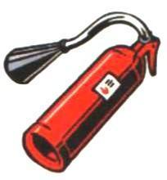
- All snack shack personnel are to be instructed in the use of fire extinguishers.
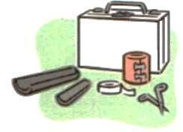
- A fully stocked First Aid Kit will be placed in the Snack Shack. An AED is available at the Robert Livermore field.

- The snack shack main entrance door will not be locked or blocked while people are inside.

Storage Shed/Bin Procedures
The following applies to all equipment bins and storage sheds used by Livermore Little League and applies to anyone who has been issued a key by Livermore Little League to use those bins/sheds.

- All individuals with keys to the Livermore Little League equipment bins/sheds (i.e., Managers, Umpires, etc.) are aware of their responsibilities for the orderly and safe storage of rakes, shovels, bases, golf carts, lawn mower etc.

- Before you use any machinery located in the bins/shed (i.e., golf cart, lawn mowers, weed whackers, lights, scoreboards, public address systems, etc.) please locate and read the written operating procedures for that equipment.

- All chemicals or organic materials stored in Livermore Little League bins/sheds shall be properly marked and labeled as to its contents.

- All chemicals or organic materials (e.g. lime, fertilizer, etc.) stored within the equipment bins/sheds will be separated from the areas used to store machinery and gardening equipment (e.g. rakes, shovels, etc.) to minimize the risk of puncturing storage containers.

Any witnessed "loose" chemicals or organic materials within the bins/sheds should be cleaned up and disposed of as soon possible to prevent accidental poisoning.

Safety is EVERYONE’S responsibility

Livermore Little League goes to great lengths to provide as much training as possible. Attend as many of the clinics as possible.

Check the Livermore Little League Home Page frequently. Lots of information and a complete league calendar can be found there and can be a very valuable resource:

www.livermorelittleleaque.corn

Remember, safety is everyone's responsibility. Prevention is the key to reducing accidents to a minimum. Report all hazardous conditions to the Safety Officer or another Board member immediately. Don't play on a field that is not safe or with unsafe playing equipment. Be sure your players are fully equipped at all times, especially catchers and batters. And, check your team's equipment often.

Accident Reporting Procedure:

What to Report: An incident that causes a Payer, Manager, Coach or Umpire to receive medical treatment or first aid must be reported to The Safety Officer.

When to Report: All such incidents described above must be reported to The Safety Officer within 24 to 48 hours of the incident.

The Safety Officer is: NAME: Kari Weber
Cell Number: 925.784.3622
Email: Safety@LivermoreLittleLeague.com

How to Make a Report: Reporting incidents can come in a variety of forms. Most typically they are telephone conversations. At a minimum, the following information is needed.
- The name and address of the injured person.
- The date, time, and location of the incident.
- As detailed of a description of the incident as possible.
- The preliminary estimation of the extent of the injury.
- The name and phone number of the person making the report.
- Names and phone number of any witnesses.

In your safety packet you will find the injury report forms. If your Safety Parent is there, he/she can assist you in getting the front of the form filled out. Then a call is to be made to The Safety Officer reporting the incident within 48 hours. Little League insurance is a supplemental insurance to the insured’s own insurance. There is a $50 deductible.

Safety Officer’s Responsibilities:

Within 48 hours of receiving the incident report, the Safety Officer will contact the injured party, or the party’s parents to: 1) verify the information received 2) obtain any additional pertinent information 3) check on the status of the injured party 4) in the event the injured party required medical treatment (i.e. emergency room, doctor visit, hospitalization, etc.) will advise the parent or guardian of Little League insurance coverage and the provision for submitting any claims.

If the extent of the injury is more than minor in nature, the Safety Officer will periodically call the injured party to (1) check on the status of the injured party and injury, and (2) to check in any other assistance is necessary in area such as submission of insurance forms, etc. until the incident is considered closed (meaning no further claims are expected and the individual is able to participate in league activities again).

Emergency Procedures
Earthquake: If outdoors, move away from buildings, streetlights, large trees and utility wires. Sit down on the field. If indoors, get under -- and hold onto --a desk or table, or stand against an interior wall. Stay clear of exterior walls, glass, heavy furniture, fireplaces and appliances. Note: Field lights may burst. Stay away from windows and do not use an elevator. After the earthquake, move outdoors and prepare for aftershocks.

Suspicious Package: If you see a suspicious package, do not open it, shake it or carry it to another location. Ask those in the area if it belongs to them. If reasonable measures have been taken to identify the owner of the package with no success, make those in the vicinity aware of its presence and contact the police.

Missing Child: Initially ask adult volunteers to search the area including bathrooms, neighboring fields, nearby play areas, behind the outfield fence, etc. Ask the child’s guardian if another family member or friend may have given the child a ride. Do not allow children to search without an accompanying adult. If a child cannot be located after a cursory search, the police should be informed that a child is missing. In the meantime, all remaining children should be accounted for and kept under the supervision of adults. Make note of any suspicious people/cars/activity. Help the police by collecting as much current information on the child as possible including the clothing they were wearing, their height, weight and age, the last known location and who they last spoke with before going missing.

Telephone Bomb Threat: Keep the caller on the line as long as possible while gathering information about the caller, the bomb and its location. If possible, record the conversation. Do not hang up, even if the caller does -- Use another phone to call the police. Immediately write down as much information as you can remember, making note of accents, phrasing, speech irregularities or any background noises. After calling police, inform ANY Board Member of the situation.

Active Shooter: Livermore Little League fields are outdoors, and therefore a lockdown procedure is not practical. Instead, the Dept of Homeland Security Options-Based approaches should be implemented in the following order:

- RUN: If there is an accessible path away from the gunfire, leave belongings behind and evacuate. Do so even if others do not follow. Attempt to follow a path that offers camouflage, an obstructed view or shielding (e.g. walls, trees, fence lines). Avoid running through open fields (especially in groups). If possible, run with your head low in a zig-zag pattern. Call 911 when it is safe to do so. If police are present, run with your hands up.

- HIDE: Shelter out of the active shooter’s view in any area that offers protection from gunfire. Stay low. Pick a spot that will not trap you or restrict your movement. Silence your cell phone and remain as quiet as possible. Dial 911, if possible, to alert police to the active shooter’s location. If you cannot speak, leave the line open and allow the dispatcher to listen.

- FIGHT: As a last resort, take action. Disrupt or incapacitate. Act aggressively. Throw items (balls) or use improvised weapons (bats). Yell, scream, poke, scratch, bite. Commit to your actions (it’s your life or theirs). Spread out and attack from different angles.

If you see something, say something. Many recent shooting events were perpetrated by current or former members of the organization/school who spoke openly of their intentions. If someone makes a threat of violence, brings a weapon to a game or practice or makes any claim to harm other either in person or through social media, alert the authorities.
With any emergency, please contact any Board Member to report. Individual team members should make the Manager/Coach aware of their status. This will help expedite communication. Public announcements will be made through LivermoreLittleLeague.com. Questions from the public or press should be directed to the information officer at info@livermorelittleleague.com.

it is suggested this memo should be reproduced on your league's letterhead over the signature of
your president or safety officer and distributed to the parents of all participants at registration time.

WARNING: Protective equipment cannot prevent all injuries a player might receive while participating in
Baseball / Softball.

WHAT PARENTS SHOULD KNOW ABOUT Little League Insurance

The Little League Insurance Program is designed to afford protection to all participants at the most economical cost to the local league. The Little League Player Accident Policy is an excess coverage, accident only plan, to be used as a supplement to other insurance carried under a family policy or insurance provided by an employer. If there is no primary coverage, Little League insurance will provide benefits for eligible charges, up to Usual and Customary allowances for your area. A $50 deductible applies for all claims, up to the maximum stated benefits. This plan makes it possible to offer exceptional, affordable protection with assurance to parents that adequate coverage is in force for all chartered and insured Little League approved programs and events. If your child sustains a covered injury while taking part in a scheduled Little League Baseball or Softball game or practice, here is how the insurance works:
- The Little League Baseball and Softball accident notification form must be completed by parents (if the claimant is under 19 years of age) and a league official and forwarded directly to Little League Headquarters within 20 days after the accident. A photocopy of the form should be made and kept by the parent/claimant. Initial medical/dental treatment must be rendered within 30 days of the Little League accident.
- Itemized bills, including description of service, date of service, procedure and diagnosis codes for medical services/ supplies and/or other documentation related to a claim for benefits are to be provided within 90 days after the accident. In no event shall such proof be furnished later than 12 months from the date the initial medical expense was incurred.
- When other insurance is present, parents or claimant must forward copies of the Explanation of Benefits or Notice/ Letter of Denial for each charge directly to Little League International, even if the charges do not exceed the deductible of the primary insurance program.
- Policy provides benefits for eligible medical expenses incurred within 52 weeks of the accident, subject to Excess Coverage and Exclusion provisions of the plan.
- Limited deferred medical/dental benefits may be available for necessary treatment after the 52-week time limit when (a) Deferred medical benefits apply when necessary treatment requiring the removal of a pin /plate, applied to transfix a bone in the year of injury, or scar tissue removal, after the 52-week time limit is required. The Company will pay the Reasonable Expense incurred, subject to the Policy's maximum limit of $100,000 for any one injury to any one Insured. However, in no event will any benefit be paid under this provision for any expenses incurred more than 24 months from the date the injury was sustained. (b) If the Insured incurs Injury, to sound, natural teeth and Necessary Treatment requires treatment for that Injury be postponed to a date more than 52 weeks after the injury due to, but not limited to, the physiological changes of a growing child, the Company will pay the lesser of: 1. A maximum of $1,500 or 2. Reasonable Expenses incurred for the deferred dental treatment.
Reasonable Expenses incurred for deferred dental treatment are only covered if they are incurred on or before the Insured's 23rd birthday. Reasonable Expenses incurred for deferred root canal therapy are only covered if they are incurred within 104 weeks after the date the Injury occurs. No payment will be made for deferred treatment unless the Physician submits written certification, within 52 weeks after the accident, that the treatment must be postponed for the above stated reasons. Benefits are payable subject to the Excess Coverage and the Exclusions provisions of the Policy.

We hope this brief summary has been helpful in providing a better understanding of the operation of the Little League insurance program.

Little League Baseball and Softball

Claim Form Instructions
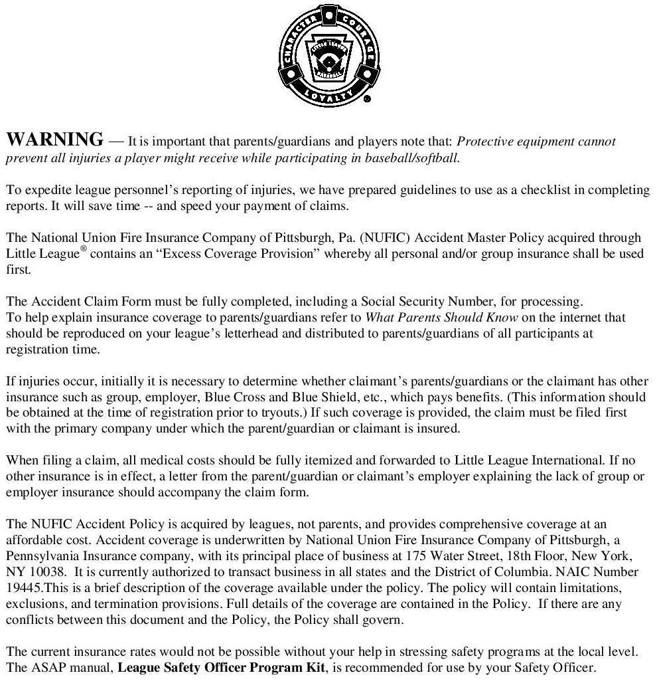

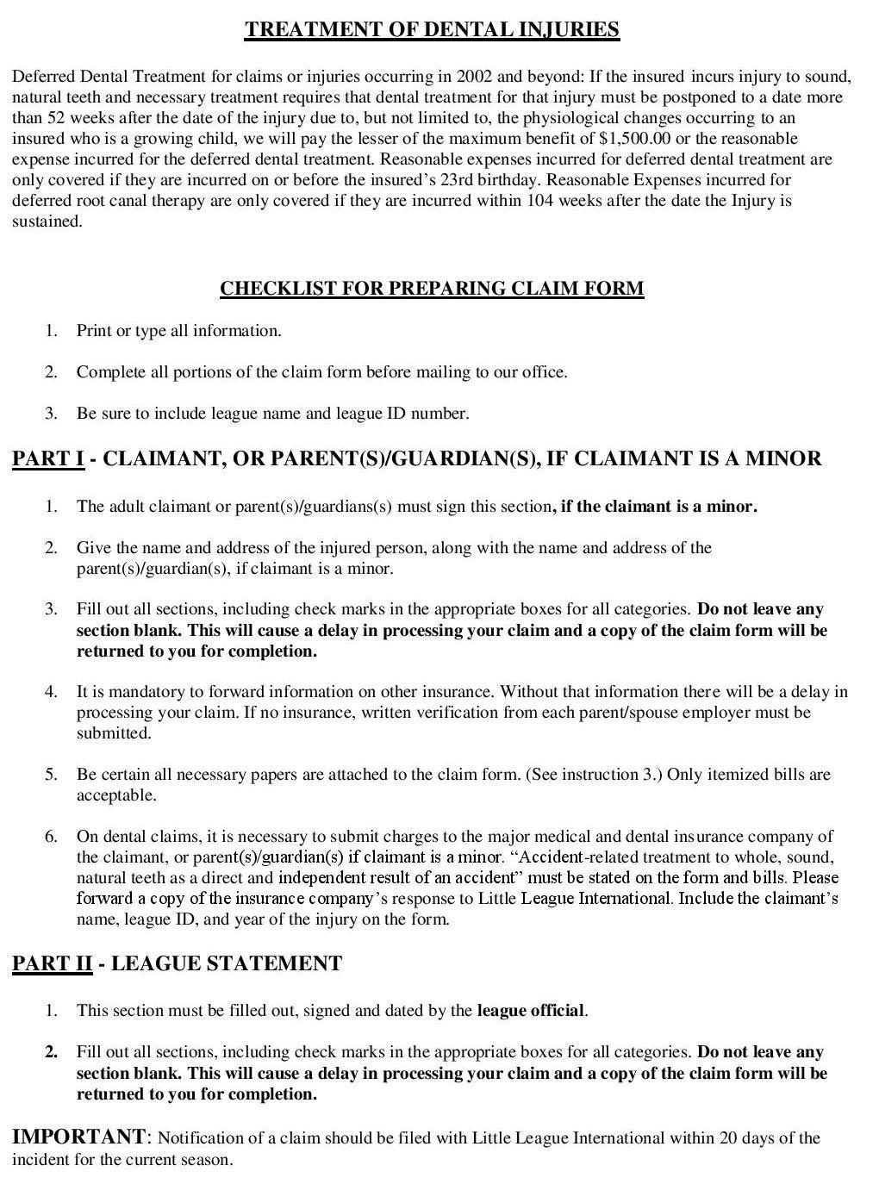

Accident Claim Form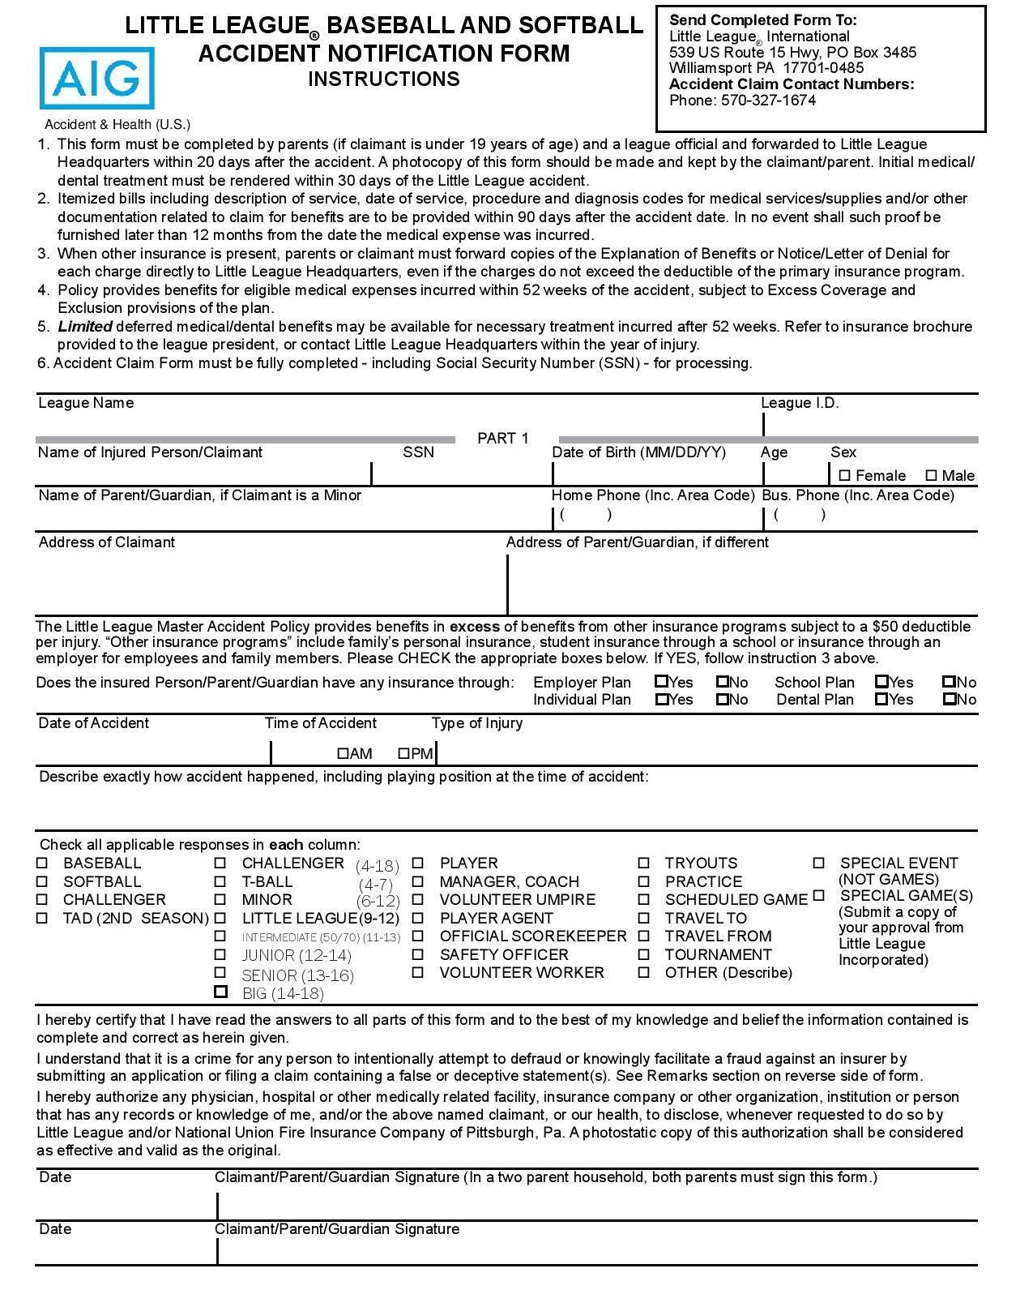

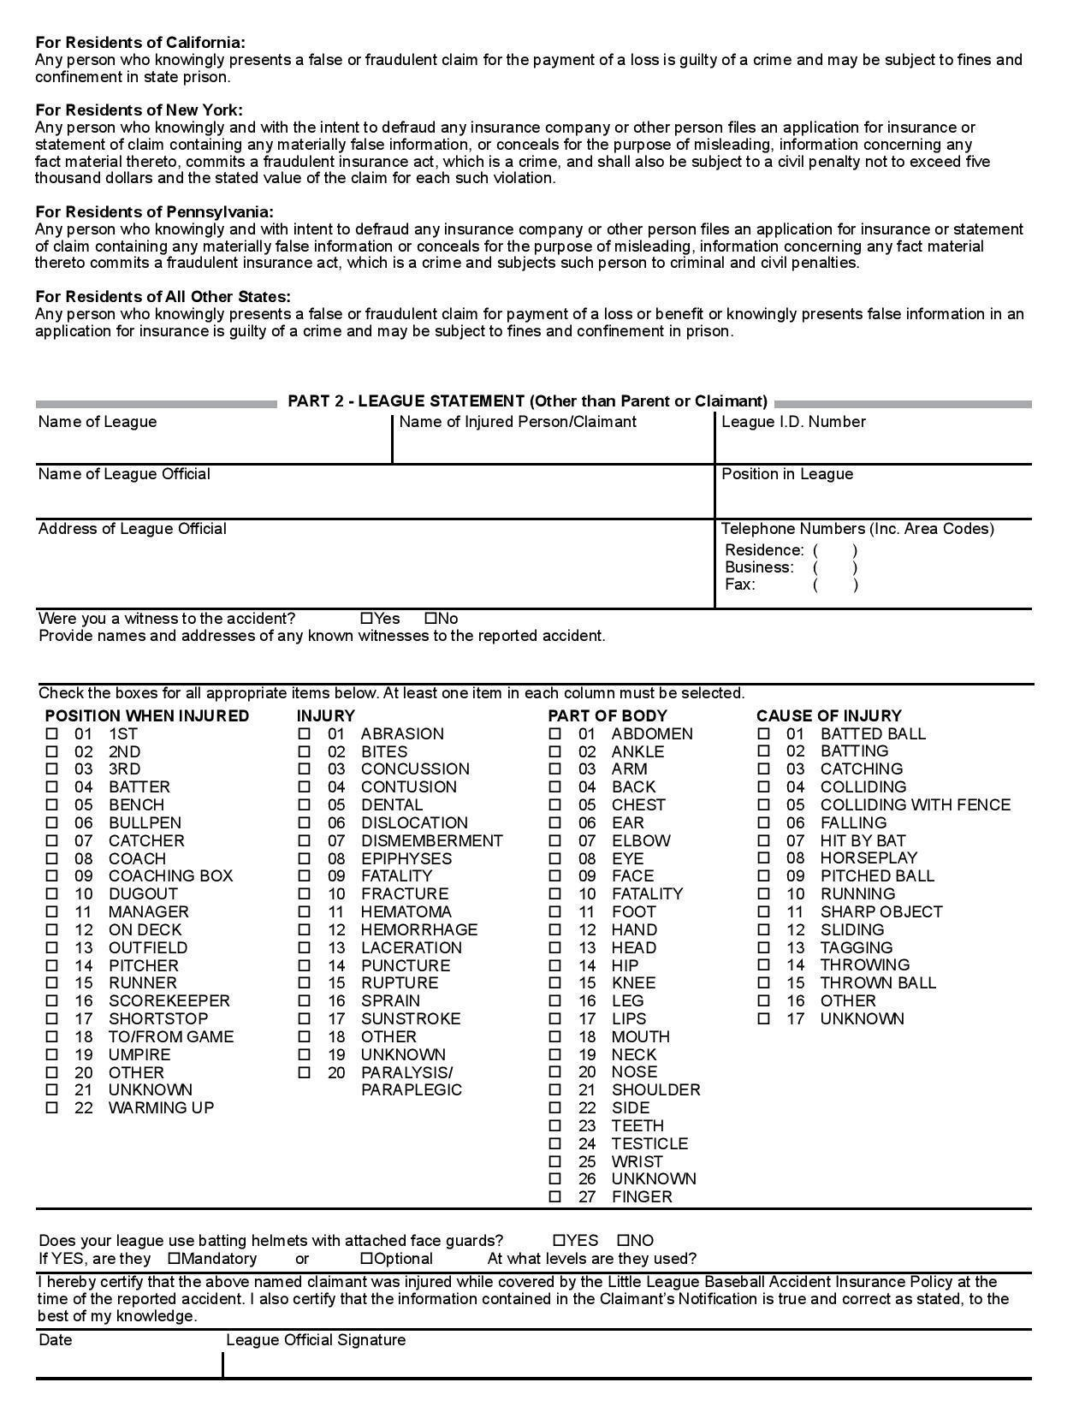
Safety Officer’s Responsibilities:

Within 48 hours of receiving the incident report, the Safety Officer will contact the injured party, or the party’s parents to: 1) verify the information received 2) obtain any additional pertinent information 3) check on the status of the injured party 4) in the event the injured party required medical treatment (i.e. emergency room, doctor visit, hospitalization, etc.) will advise the parent or guardian of Little League insurance coverage and the provision for submitting any claims.

If the extent of the injury is more than minor in nature, the Safety Officer will periodically call the injured party to (1) check on the status of the injured party and injury, and (2) to check in any other assistance is necessary in area such as submission of insurance forms, etc. until the incident is considered closed (meaning no further claims are expected and the individual is able to participate in league activities again).

FUNDAMENTALS TRAINING: All Pro Baseball Coaching Clinic
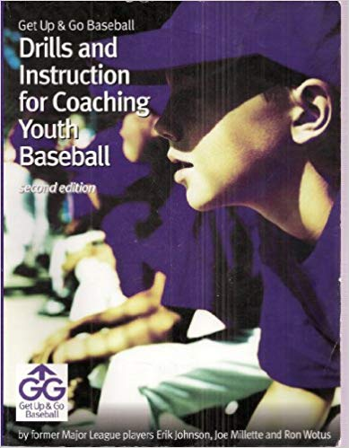
All Pro Baseball Clinic (tbd)

All Pro Baseball group has been speaking to coaches throughout the USA for 28 years. The instruction they provide covers fundamentals including hitting, sliding, fielding, pitching and more, geared for Little League.

Established in 1988, by former professional baseball players Erik Johnson and Joe Millette along with San Francisco Giants Bench Coach, Ron Wotus, All Pro has taught over 1000 coaching clinic presentations for youth and professional coaches.

They instruct from a book they authored called “Drills and Instruction for Coaching Youth Baseball.” Copies of this book are provided to each coach in attendance.

The time and date for this clinic will be announced on the Livermore Little League website. The clinic may be attended by all, but minimally, 1 manager or coach from each team must attend.

Team/Coach Checklist:

GAME-TIME RESPONSIBILITIES | HOME TEAM  (3rd base dugout) | AWAY TEAM  (1st base dugout)
Pre-game
Inspect all gear/equipment. Contact the League’s Equipment Mgr if defective. | ⋅ | ⋅
Bring scorebook | ⋅
Bring completed pitching affidavit | ⋅ | ⋅
Uniform and equipment check for each player on team. * | ⋅ | ⋅
Bring 2 fresh baseballs for the game | ⋅
Walk the field to look for hazards like rocks, glass, holes, foreign objects, etc.** | ⋅
Wet and drag the field before the game | ⋅
Chalk field lines | ⋅
Bring a completed lineup card for the umpire | ⋅ | ⋅
Have each player’s medical release form | ⋅ | ⋅
Bring water for your players (on fields without drinking fountains) | ⋅ | ⋅
Bring a fully stocked first aid kit. Contact LLL Safety officer for replacements. | ⋅ | ⋅
Post-game
Clean trash from each dugout and around the grandstands |  | ⋅
Wet and drag the field after the last game of the day. |  | ⋅
For last game of the day, put away scoreboards/bases. Lock dugouts & shed. |  | ⋅

* If safety equipment is damaged or lost, please contact the equipment officer (equipment@livermorelittleleague.com). Damaged equipment should not be thrown away. Instead, return it to the League’s equipment manager for repair or proper disposal.

** Field hazards (e.g. remove rocks or glass, fill small holes, zip-tie dugout screens, etc) must be resolved before practices and games commence. Note: spectators seated inside the foul or home run fence-lines are considered a hazard and must be instructed to move off the field. If field hazards are found that require more extensive repair, contact the fields officer before play.

Medical Release Form:
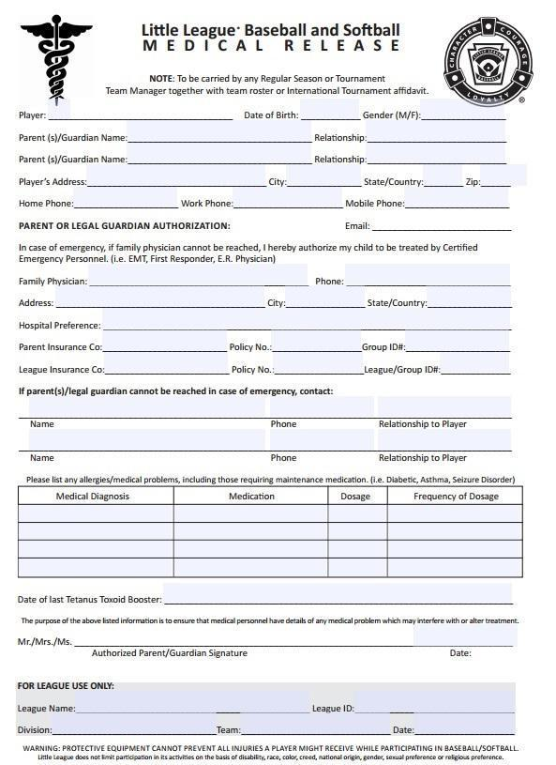

Pitching & Catching Affidavit
